Growing Old Crib Sheet

Death and taxes may well both be inevitable, and, both need to be accordingly planned for. Apart from which, luck, or chance, may well bestow the experience of advancing, or even old, age, and all that goes with this consequent physical plus mental condition. Planning for an easing of the accompanying stresses is important, so, some tips are hereby offered:

1) Be realistic, Give in gracefully, mentally and physically, viz, in both cases, understand that you are no longer just keeping fit, but, also wearing out more quickly...so, best to ease activities, from ‘keep fit’ to just ‘keep active’, and even that within reasonable limits. Avoid being over-stressed mentally, keep up with sleep and relaxation. Just remember, though, that what you do not use, Nature takes away. Act graciously towards those who would offer help, however formal or informal, being respectful of your age.

2) ‘Use it or loose it’ applies to wits, brainpower, and physical health and fitness; all must be conserved with useful activities that require optimal mental involvement. Consider carefully the clinical changes to be faced, rather than just lamenting physical decline, for the sake of morale! As for the physical and mental changes....observe and report as necessary.....suggest regarding this as some sort of hobby study….such objectivity will be more beneficial than just noting, and lamenting, general deterioration!

3) Do not burden others with the consequences of irresponsible behaviour, and do not leave a legacy of legal messes and loose ends. Make sure your Will and personal affairs are current. Make sure you have reliable executors, and co-opt dependable power-of-attorney holder(s). Make a Living Will whilst your mental condition is sound, especially in these more enlightened times, when a personal choice of death with dignity is a reality.

4) Domicile is important….so much of this aspect is common sense, viz, live at ground level, or very near...unless you have the means to install lifts. Install stair-rails and wide, non-slip treads where necessary. Live with a planned layout that does not impede movement, always leave a night light on. Be careful of everyday hazards like slippery surfaces, climbing ladders, carrying weights, crossing roads, et al.

5) Diet and sleep are both involved with keeping fit, active, and mentally acute. In cool and temperate climates, avoid inactivity whilst cold, especially involving extremities, and, in warmer climates, be well-hydrated, and cool. Get the best advice for both from your GP, and/or, paramedic such as nutritionist sand occupational therapists. https://www.telegraph.co.uk/health-fitness/diet/nutrition/mind-diet/ Avoid taxing mental activities such as arguments and confrontations, plus any other repetitive stresses, mental or physical. Most importantly, be aware of your own slower reaction times, and declining physical strength and endurance, especially using power tools, and most importantly, when operating complex machinery, which includes driving motor vehicles.

6) If you are subject to scrutiny, for whatever reason, as to your ‘fitness’ or ‘independence’, plan, be organised, tidy, and up-to-date, plus, make sure you already have the help needed to achieve and maintain these standards. Keep regular hours, including meals, plus, have careful, organised, and time-dedicated medication regimes. Noticeboards, calendars, et al, in obvious regular use, plus, bills paid, organised kitchen, current food-dates, general tidiness and cleaning standards….all help to support claims of physical capability, and enduring compis mentis..!

7) Have ambulance membership, and beware of well-meaning people calling ambulances on your behalf...’3 strikes and you are in a Rest Home’ may result, as other people acting on your behalf, in presumed emergencies, may well be interpreted as general loss of independent thought and action.

8) Communal living certainly has its advantages, though strata title and other such exploitative financial schemes are to be avoided. Be wary also, of sudden or unbidden 'friendships'...and retain a trustworthy lawyer!

9) Being realistic is also a major part of financial management when older…shed those increasingly unneeded financial ties, and, asset drains, that eat into your financial reserves. Have a potlatch, or, consult your legatees in advance, re disposing of your assets, large and small. These important steps will also help ease any remaining rage, at that unwanted dying of the light. Thus, do not leave debts, plus, do not run into credit with any utilities, funeral directors, et al….any such credit will NOT be refunded to your heirs!

10) Quote from an aging realist: ”Do not burden others, so ensure you down size and get rid of the junk. You are not a museum of memories, and, the kids don't want your stuff!!’’

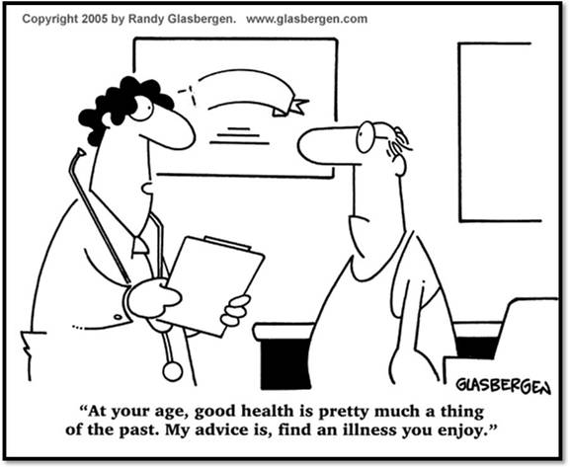

Home http://nofrillstech.net/

